

##### Question/Answer Booklet

Name: marking key

PHYSICAL EDUCATION STUDIES

Yr 11 ATAR 2021

**Semester 1: Class Test 1**

**Time allowed for this paper**

Working time for paper: 45 minutes

**Material required/recommended for this paper**

*To be provided by the supervisor*

This Question/Answer Booklet

|  |  |  |  |
| --- | --- | --- | --- |
| **Contents:**  Motor Learning and  Coaching | 18 Questions | **Total marks** | **/50** |

**Multiple Choice (10 marks)**

1. Throwing a dart, can be classified as a:

(a) Discrete, Closed motor skill.

(b) Continuous, Open motor skill.

(c) Serial, Closed motor skill.

(d) Gross, Open motor skill.

1. Augmented feedback in which a coach provides information regarding the outcome or success of the movement to their athlete, is known as:
2. specific feedback.
3. knowledge of results.
4. knowledge of performance.
5. knowledge of feedback.
6. In an offensive play of NFL gridiron, the quarterback receives the ‘snap’ pass from the centre, then looks to throw the ball downfield to an eligible receiver who is covered by a defending player, the quarterback then decides to run with the ball himself. According to the information-processing model, what stage of the model did the quarterback reach?
7. Identification of stimuli/input.
8. Response identification/decision-making.
9. Response/output.
10. Feedback.
11. A ten-pin bowler who watches the ball spin and travel path down the lane before then hearing the ball strike into the pins is receiving:

1. extrinsic feedback.
2. augmented feedback.
3. intrinsic feedback.
4. knowledge of performance.

5. During an Inter-School basketball game, a coach shouts out to her players ‘zone defence’, as the ball is turned over from a rebound. This is an example of:

(a) Terminal feedback.

(b) Concurrent feedback.

(c) Constructive feedback.

(d) Intrinsic feedback.

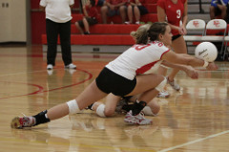6. In receiving a serve over the net, Phillipa decides to dig and moves accordingly. With reference to the Information Processing Model, this action is known as:

(a) Input.

(b) Output.

(c) Stimulus.

(d) Decision making.

7. Which of the following skills can be classified as the most discrete skill?

(a) 110m hurdles.

(b) Swimming 100m.

(c) Basketball free throw.

(d) Basketball lay-up

8. Knowledge of results is an example of:

(a) Inherent feedback.

(b) Concurrent feedback.

(c) Extrinsic feedback.

(d) Intrinsic feedback.

9. The day after a failed attempt at the Red Bull Cliff Diving, an athlete is told by her coach that she needed to get into her tuck earlier to allow for full extension prior to hitting the water. This feedback is

(a) external augmented, knowledge of performance, terminal.

(b) external augmented, knowledge of performance, concurrent.

(c) external intrinsic, knowledge of performance, terminal.

(d) external augmented, knowledge of result, concurrent.

10. During the second phase of learning, athletes should be encouraged to:

(a) Use their own feedback to detect and correct errors.

(b) Keep the learning environment exactly the same.

(c) Increase their reliance on augmented feedback to perfect the skill.

(d) Develop an understanding of how to perform the skill.

**Short Answer (30 marks)**

**Question 11 (6 marks)**

Games can be classified into variety of categories. From column A, provide the correct categories for the various games listed. Choose the correct classification from the choices listed here and write them opposite the game in column B.

Direct interceptive, Indirect interceptive, Performance Activities, Aesthetic Activities.

|  |  |
| --- | --- |
| A | B |
| Touch Rugby | DI |
| Netball | DI |
| Gymnastics | A |
| Cricket | II |
| Badminton | II |
| Swimming | P |

**Question 12 (8 marks)**

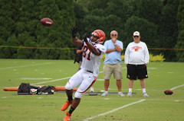

Using your understanding of the information-processing model, explain how to successfully execute the catch.

3. Response / Output

1 MARK

The selected movement response is executed

1 MARK

2. Response identification / Decision making 1 MARK

Athlete’s brain processes data for interpretation and formulates an appropriate response/movement

1 MARK

4. Feedback

1 MARK

Performance is evaluated from self, coach or other observer

1 MARK

1. Input/identification of stimulus

1 MARK

Athlete identifies the ball and other relevant cues 1 MARK

**Question 13**

Place the following activities (A, B, C, D) on the continuum below. **(2 marks)**

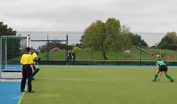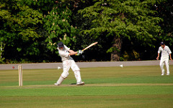

1. Cricket stroke **B**. Penalty stroke (green shirt)

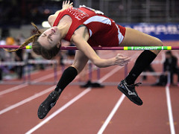

**C**. High jump **D**. Surfing

Penalty stroke

Cricket stroke

Surfing

High jump

**OPEN CLOSED**

**Question 14 (4 marks)**

Four-time AFL premiership player Luke Hodge is nearing the end of his playing career. He mentioned in a recent interview that when he retires, he is looking forward to coaching his own children’s junior football team. Other than age, explain **two** individual differences that Luke will need to consider when coaching his children’s team and explain how he would have to alter training to cater for these differences.

|  |  |
| --- | --- |
| **Marks** | **Elaboration** |
| Max 2 marks  1 mark each | Explanation – choose any 2 from   * Skill level – how experienced and physically able the players are * Fitness level – the players level of physiological capacity and ability to train/play at high intensity * Injury – any condition or impairments that inhibit players ability to train/play * Level of competition – the standard of play expected in a particular league or competition   Nature of activity – the type of sport/game and the physical/mental demands placed on the players |
| Max 2 marks  1 mark each | How to cater for these differences (accept the following or similar response)   * Skill level – Skill level will be low in young children so complex drills should be avoided and more simple skill learning drills utilised * Fitness level – Fitness levels in young children will be low so training sessions will need to be shorter and less intense to begin with * Injury – All injured players should still be included in any activities they are capable of but kept from competing in activities that will make the injury worse * Level of competition – All players and teams are inexperienced so focus should be on skill learning and development as opposed to strategy and tactics * Nature of activity – training should focus on preparing players to perform all skills required in a football game |

**Question 15 (4 marks)**

The following graph displays data for two (2) athletes practicing their goal kicking in AFL.

(a) Using the data from the graph, identify which athlete was most likely to be in the

cognitive stage of learning. Justify your response

(2 marks)

|  |  |
| --- | --- |
| Description | Marks |
| Athlete B | 1 |
| Greater rate of improvement | 1 |
| Started at a lower level (i.e. lower success rate) | 1 |

(b) Using the data from the graph, identify which stage of learning the other athlete

was most likely to be in. Justify your response

(2 marks)

|  |  |
| --- | --- |
| Description | Marks |
| Athlete A – Associative stage | 1 |
| Reduced rate of improvement | 1 |
| Moderate level of performance | 1 |

**Question 16 (2 marks)**

Athletes require multiple types of feedback to improve their performance. Explain the difference between internal and external feedback when performing a skill.

|  |  |
| --- | --- |
| Description | Max 2 marks |
| **Internal feedback** – Received from sensory receptors inside muscles, joints and tendons which provide information to the athlete about their execution of the skill. eg. Proprioception, kinaesthetic awareness | 1 mark |
| **External feedback** – Is the information received from outside the body. It is received by the sensory system and is seen, felt or heard. eg. Verbal feedback from coach / teammates / crowd / scoreboard results related to execution of the skill / video footage. | 1 mark |

**Question 17 (4 marks)**

Cyclists in the Tour de France cycling race compete in teams and have support vehicles which provide nutrition, technical equipment and coaching support. Information on the race is also communicated via in-ear radio which provides feedback aiding in the potential success of the cycling team. Explain **two (2)** purposes of providing feedback to cyclists in such a race as the Tour de France.

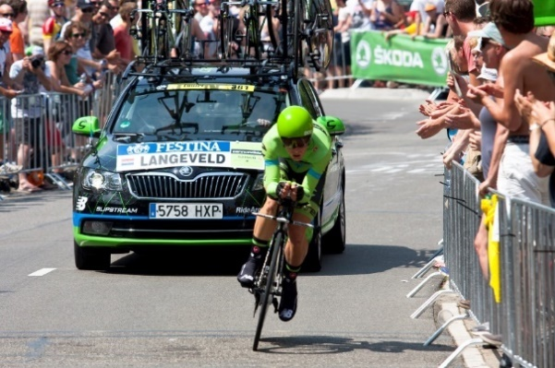

|  |  |
| --- | --- |
| Description (Any two of the following) | Max 4 marks |
| **Feedback for reinforcement**  Reinforce what has been achieved so that cyclist can repeat what is required in team tactics / race finish  **Feedback for motivation**  Providing positive feedback to support, encourage, recognise cyclist and/or their efforts  **Feedback to modify performance**  Providing constructive feedback about positive aspects and areas to improve within the race. (eg. Upcoming mountain / sprint stage section) | 1 mark for purpose  1 mark for explanation  1 mark for purpose  1 mark for explanation  1 mark for purpose  1 mark for explanation |

**Extended Answer (10 marks)**

**Question 18 (10 marks)**

Joe has never played tennis and is practising his serve.

State Fitts and Posner’s three phases of learning, clearly identifying Joe’s current phase, and describe **two (2)** characteristics you would expect to see in his performance during this phase. As Joe’s coach, identify **two (2)** types of cues you can use with a relevant example to assist Joe in moving to the next phase of learning.

|  |  |
| --- | --- |
| Marks | Possible answer |
| 1 mark each (max. 3) | **Phases of Learning**  Cognitive phase  Associative phase  Autonomous phase |
| 1 mark phase  1 mark for each description (max. 2) | **Joe’s phase:**  *Cognitive*   * Large variability between performances; lack consistency * By errors that tend to be large * Unable to identify and correct own errors; lack knowledge * Rely on feedback |
| 1 mark for explanation of cue (max. 2)  1 mark for relevant example (max. 2) | **Cues**  *Any two of the following:*  Visual cues   * Visual demonstration of what is required and performance result * Example – visual image/model of ideal serve technique or other relevant example   Verbal cues   * Auditory explanation/feedback that is usually delivered in conjunction with visual cues. * Example – providing cue words such as “watch the ball”   Proprioceptive cues   * Experiencing the correct feeling of a successful performance * Example - physically placing body part in correct position. |